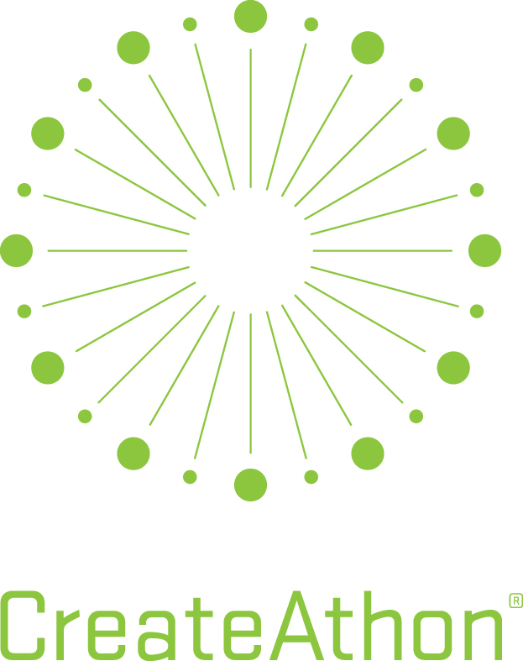
750 Meeting Street
West Columbia, SC 29169
803.799.5972 T
803.779.8447 F
www.riggspartners.com

Riggs Partners 2017 CreateAthon Application

GENERAL INFORMATION

Organization Name:
Address:
Contact Name/Title:
Phone:
E-Mail Address:

ORGANIZATION INFORMATION

Please describe the organization’s mission.

Is your organization listed as a 501(c)(3)? | Yes |  | No
501(c)(3) Number (Only 501(c)(3)-designated nonprofits are eligible.)
What year was the organization founded?
Where is the organization headquartered?
What is your service area?
Does your organization provide direct services or is it an association/coalition?
Did your organization budget for marketing or public relations expenditures this year? | Yes |  | No
If yes, how much? | $

Is your organization currently working or planning to work with any other | Yes |  | No
marketing or public relations firm on a paid or pro bono basis?
If yes, who?
Is your organization working with any other type of paid consultant? | Yes |  | No
If yes, who?
Have you applied for CreateAthon previously? | Yes |  | No
Been selected as a recipient? | Yes |  | No

MARKETING AND COMMUNICATIONS OBJECTIVES

Describe the primary issues or needs affecting your organization that you believe effective marketing and communications can help to solve (in detail, please!)

CREATIVE DELIVERABLES

In order of priority, provide a description of any specific projects you’d like us to consider producing. Examples include brand strategy or messaging development; marketing plan; PR strategy; fundraising case for support; logo refresh or redesign; letterhead package; commercial or video storyboard; poster; website plan; content or production; social media program; and others.

Describe each project as indicated. Feel free to add additional projects or details.

Project One – Urgent Priority

Project Description:

What need will this address:

Who is the intended target?

Tied to a specific timeframe or event date?

What will make this a success for you?

Please share any insights to assist with production.

Project Two – High Priority

Project Description:

What need will this address:

Who is the intended target?

Tied to a specific timeframe or event date?
What will make this a success for you?

Please share any insights to assist with production.

Project Three

Project Description:

What need will this address:

Who is the intended target?

Tied to a specific timeframe or event date?

What will make this a success for you?

Please share any insights to assist with production.
Project Four

Project Description:

What need will this address:

Who is the intended target?

Tied to a specific timeframe or event date?

What will make this a success for you?

Please share any insights to assist with production.

Please add additional projects to your scope as needed.

PRODUCTION RESOURCES

Which board members or key decision makers within the organization will provide project input and review/approve the work?

Name | Title

Do you have a marketing or communications director or other staffer to coordinate follow-up production such as printing? | Yes |  | No
If yes, who?
Resource or vendor for website development or email marketing? | Yes |  | No
If yes, who?
Resource or vendor for public relations or social media tactics? | Yes |  | No
If yes, who?
Pre-existing resource, vendor or arrangements for free media space? | Yes |  | No
If yes, who?

RIGGS PARTNERS CREATEATHON 2017 SELECTION PROCESS

Application Deadline to Riggs Partners: | July 15, 2017
Selected Candidates Notification: | Week of August 28, 2017
Submit your completed application, along with a $50 application fee made payable to CreateAthon, via mail to:
Riggs Partners
Attn: Yanti Pepper
750 Meeting Street
West Columbia SC 29169

NOTE: The $50 application fee is a tax-deductible gift to the national CreateAthon organization, a 501(c)(3) nonprofit. Funds are used to help cover the administrative costs associated with recruiting and onboarding more marketing and communications agencies, university students, professional marketing/PR/design organizations, and corporate marketing groups into the CreateAthon service network.
These efforts will help to bring CreateAthon events to more communities throughout the country, thereby delivering more pro bono marketing services to more nonprofits like yours.

None of the application fee income is directed to Riggs Partners’ local CreateAthon event. Administrative costs for this CreateAthon event are completely underwritten by Riggs Partners.
Remember to save a copy of the application for your records.

RIGGS PARTNERS CREATEATHON 2017 TERMS AND CONDITIONS

Riggs Partners will not produce work via CreateAthon that is being handled or coordinated by any type of paid consultant on behalf of the nonprofit organization, or tied to initiatives under the purview of other paid consultants.

If my organization is selected for CreateAthon, I understand and agree to the following:

- Riggs Partners will complete project work between the hours of 8:00 am Thursday, October 19, 2017 and 8:00 am Friday, October 20, 2017.
- We will meet with Riggs Partners staff in the firm’s office prior to CreateAthon (date to be determined) to provide background on the organization and any requested project(s). Riggs Partners will develop a strategic brief outlining work to be created during CreateAthon. The brief will be approved and signed by you prior to the start of CreateAthon.
- We will meet the CreateAthon project team at Riggs Partners on the morning of Friday, October 20, 2017 for a presentation of strategic and creative marketing deliverables. A specific appointment time will be scheduled.
- We will meet with Riggs Partners staff in the firm’s office during the week of October 23, 2016 to provide any changes or edits required to conclude the project. A specific appointment time will be scheduled.
- Riggs Partners will provide no additional work beyond the terms outlined above.
- Work completed during CreateAthon is the property of Riggs Partners and any third parties, such as photographers, illustrators, etc., that contribute to the projects.

☐ I have read and agree to the terms and conditions listed above.

Name of Organization:
Contact Name:
Title:
Signature:
Date:

If you have any questions, please contact Yanti Pepper at (803) 799-5972 x616.

